**Docker and Containers**

Create an instance with key pair - tflc for windows and add it’s IPV4 to putty’s session IP address

* To start putty on Virtual server

Add ip address

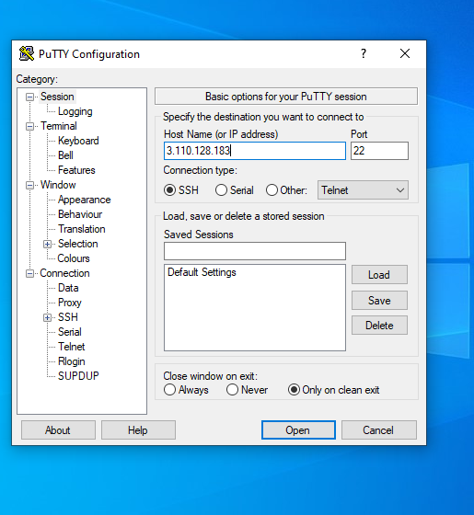

.Use key pair named as tflc.ppk for putty and add that to private key file for authentication

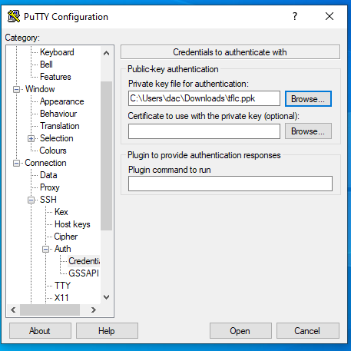

Open and accept Servers CLI will be opened

* **In putty :**

Enter username of virtual machine

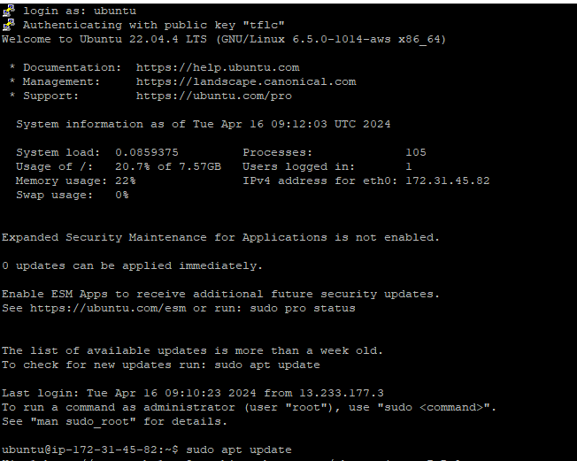

* **Install docker**

Sudo apt install docker.io

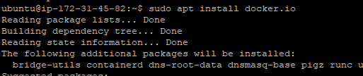

* **To check docker is active or not**

Sudo systemctl status docker

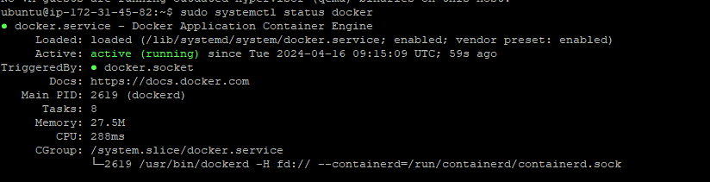

* **To check how many container are running**

Sudo docker ps



* **To check how many Container( Container images ) are available**

Sudo docker images



**For nginx web server**

* **To pull container img**

Sudo docker pull <image_name>

Sudo docker pull nginx

Src: <https://hub.docker.com/_/nginx>

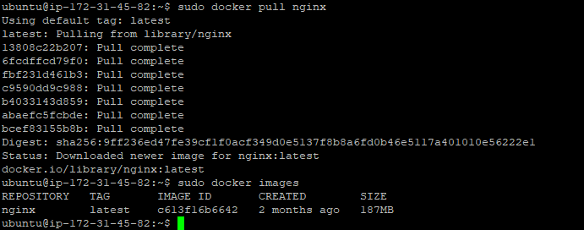

Checking images :



* **To start the server**

Sudo docker run –name <serverName> -d -p 8080:80 nginx



**Checking how many servers are running** :

Sudo docker ps



IPV4 : 3.110.128.183

To run

<http://3.110.128.183:8080>

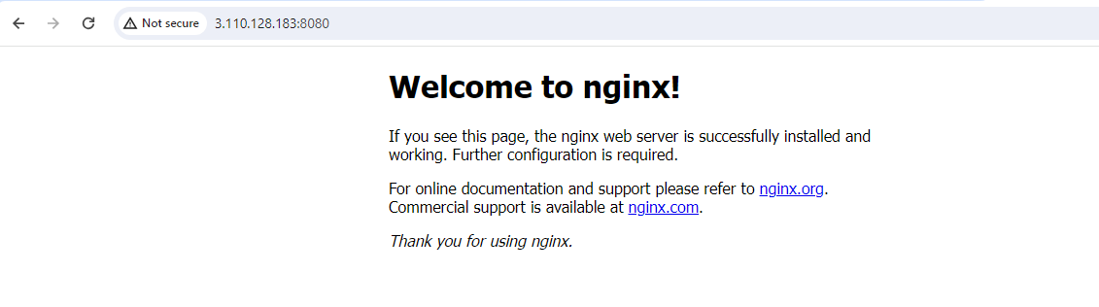

**For Tflstore git repo - web server**

1. **Clone tflstore repo**

Src : <https://github.com/RaviTambade/tflstore.git>

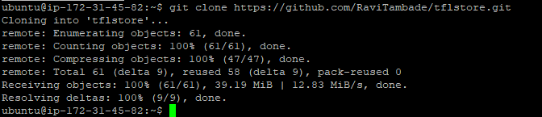

1. **To create container from dockerfile**

Cd tflstore

Sudo docker build -t tflimg .

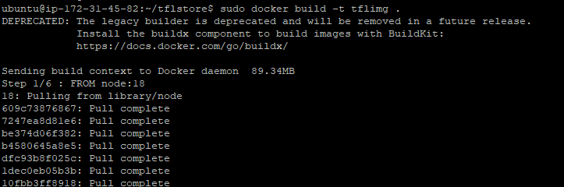

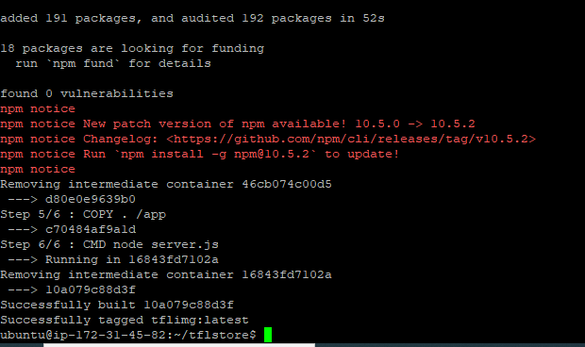

2 Container images are added

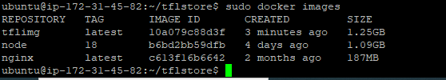

1. **To run**



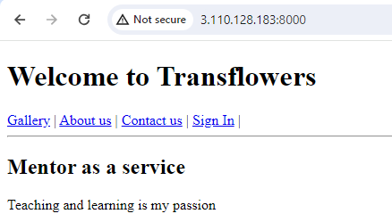



Two container are running

**For a webpage -hello-world**

* **Pulling the container image**

Src : https://hub.docker.com/_/hello-world

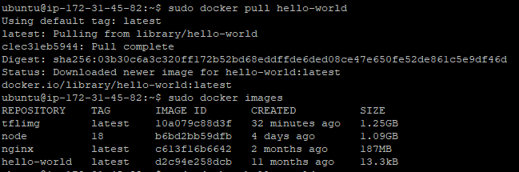

Running hello-world web page

